JULY 2019 LATEST BLUE, GREEN AND CLIMATE CHANGE ECONOMY NEWS AND DEVELOPMENTS

CLIMATE CHANGE

for IPCC Special Report on Climate Change and Land
GENEVA, June 20 – The Intergovernmental Panel on Climate Change (IPCC) will consider the Special Report Climate Change and Land …

June 2019
EXPLORE

PRESS RELEASE

IPCC circulates draft ocean and cryosphere report for final government review
GENEVA, June 14 – The Intergovernmental Panel on Climate Change (IPCC) has circulated the Final Draft including the Summary for …

June 2019
https://www.nytimes.com/2019/07/05/nyregion/climate-emergency-nyc.html

ADVERTISEMENT

A ‘Climate Emergency’ Was Declared in New York City. Will That Change Anything?
The city is now the largest on earth to pass such a measure.
Extinction Rebellion held a protest in New York City on April 17.CreditStephanie Keith/Getty Images
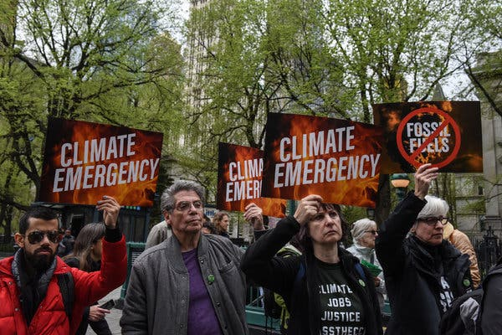
Image
Extinction Rebellion held a protest in New York City on April 17.CreditCreditStephanie Keith/Getty Images
By Anne Barnard
- July 5, 2019

[What you need to know to start the day: Get New York Today in your inbox.]
New York City, the world capital of ambition, has never been shy about grandiose declarations. The City Council has passed or proposed resolutions demanding world peace, banning a racist slur and condemning all manner of federal policies where city government has no actual say.
But for a growing global network of activists seeking to change the way the world talks about climate, the city’s sweeping resolution in late June declaring a “climate emergency” is a major victory.
Saying that the heating climate is a crisis of imminent danger, they argue that getting people and governments to describe it in far more urgent language is the only way to produce the level of global mobilization required to stop it.
New York is now the largest city on earth to pass such a measure, calling last week for “an immediate emergency mobilization to restore a safe climate.” It joined London, Sydney and a total of 722 localities in 15 countries, according to the Climate Mobilization, a Brooklyn-based nonprofit group pushing the declarations.
ADVERTISEMENT
And on Wednesday, Los Angeles’s City Council went further. It passed a measure that will formalize its own emergency declaration, calling climate change one of the most important issues facing the city. It also established a Climate Emergency Mobilization Department and laid out steps to make city agencies and the public take newly vigorous and coordinated action against planet-warming emissions.
Margaret Klein Salamon, a founder of the Climate Mobilization, an environmental advocacy group, said emergency declarations build political pressure to take stronger actions, like New York’s recent sweeping state and city laws to curb emissions.
“Because what are elected leaders supposed to do if not protect us from emergencies?” she said.

Do these words even mean anything?
By themselves, emergency declarations have no more force than other political proclamations. And just as no individual country can stop climate change within its borders, cities and states’ toolboxes are limited without the support of federal law and international agreements.
That hasn’t stopped states and smaller jurisdictions. New York City recently mandated that the owners of its largest buildings slash their emissions impact, and new legislation requires New York State to eliminate nearly all greenhouse gas output by 2050.
But questions remain about whether even these measures — with far more teeth than a council declaration — will achieve their goals.

Editors’ Picks

On the Fourth of July, Melania Trump Dresses for Independence

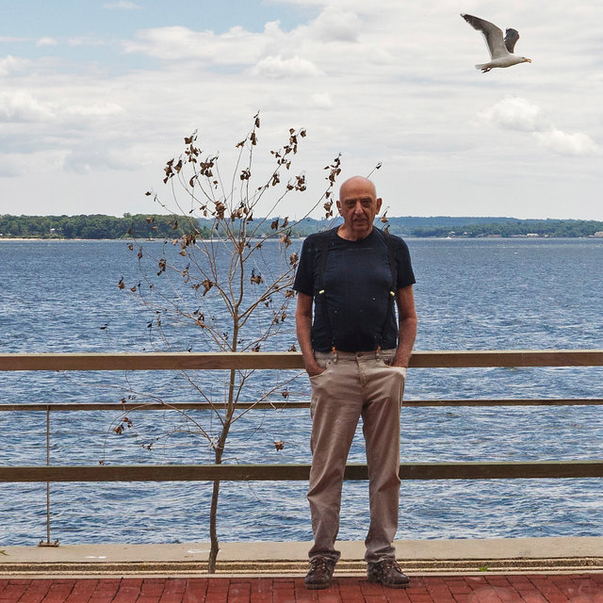

He’s Spent Just One Night on His Private Island. He’s Had Enough.

The House Where My Husband Doesn’t Exist

ADVERTISEMENT
Government agencies need to “start making things happen — and fast,” including acting against the interests of real estate, energy and other lobbies that traditionally wield political clout, said Pete Sikora, climate justice director for New York Communities for Change. His group supported the state and city laws but contends they do not go far enough.
Groups like Extinction Rebellion are calling for nonviolent civil disobedience to spur climate action.CreditStephanie Keith/Getty Images
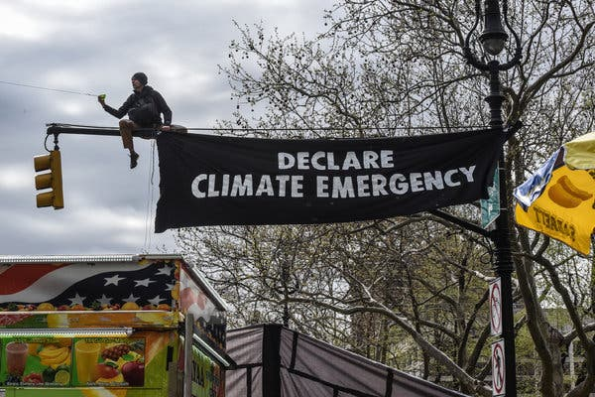
Image
Groups like Extinction Rebellion are calling for nonviolent civil disobedience to spur climate action.CreditStephanie Keith/Getty Images

Declarations have increased as public alarm has grown
The first local climate emergency was declared in Darebin, Australia, in 2016. The following year, Hoboken, N.J., became the first American city to follow suit. Groups like the Sunrise Movement and Extinction Rebellion, which calls for nonviolent civil disobedience to spur climate action, have made the declarations a centerpiece of their campaigns.
The movement has grown with extreme climate events that have been impossible to ignore: wildfires, storms and droughts, plus heat waves that set record temperatures in Europe last week and made June the world’s hottest month on record.
Last fall, the United Nations’ Intergovernmental Panel on Climate Change projected that keeping global warming at the minimum level to avert catastrophe would, as New York’s resolution put it, “require an unprecedented transformation of every sector of the global economy over the next 12 years.”
Six in ten Americans are either “alarmed” or “concerned” about global warming, according to a recent study by the Yale Program on Climate Change Communication, and the share of those choosing “alarmed” more than doubled from 2013 to 2018.

https://www.economist.com/business/2019/07/04/shells-boss-delivers-some-hard-truths-on-oil-and-climate-change

https://www.scientificamerican.com/article/climate-change-made-europes-mega-heatwave-five-times-more-likely/

ttps://www.washingtonpost.com/climate-environment/moodys-analytics-says-climate-change-could-cost-69-trillion-by-2100/2019/07/02/f9fb94ac-99cb-11e9-916d-9c61607d8190_story.html?noredirect=on

https://www.abc.net.au/news/health/2019-07-06/health-impacts-of-climate-change/11282926

https://www.independent.co.uk/environment/greta-thunberg-opec-climate-change-campaigners-oil-sector-mohammed-barkindo-a8990011.html

https://edition.cnn.com/2019/07/04/world/climate-change-lawsuits-scli-intl/index.html

https://www.cbc.ca/news/technology/tree-planting-climate-change-1.5201102

echnology & Science

Best way to fight climate change? Plant a trillion trees

This is by far — by thousands of times — the cheapest climate change solution, study co-author says
The Associated Press · Posted: Jul 05, 2019 10:29 AM ET | Last Updated: July 5

Young Macedonians plant seedling on the Vodno mountain near the capitol Skopje, The Former Yugoslav Republic of Macedonia. A new study estimates that planting a trillion new trees could suck up nearly 750 billion tonnes of heat-trapping carbon dioxide from the atmosphere. (Georgi Licovski/EPA)
2278
comments
The most effective way to fight global warming is to plant lots of trees, a trillion of them, maybe more, according to a new study. Swiss scientists also say that even with existing cities and farmland, there's enough space for new trees to cover nine million square kilometres, roughly the size of the United States.
Their report is in Thursday's edition of the journal Science.
The study calculated that over the decades, those new trees could suck up nearly 750 billion tonnes of heat-trapping carbon dioxide from the atmosphere — about as much carbon pollution as humans have spewed in the past 25 years.

A female adult jaguar sits atop a tree at the Mamiraua Sustainable Development Reserve in Uarini, Amazonas state, Brazil. Planting more trees could also preserve biodiversity, scientists say. (Bruno Kelly/Reuters)
Much of that benefit will come quickly because trees remove more carbon from the air when they are younger, the study authors said. The potential for removing the most carbon is in the tropics.

Canada has lots of room for trees
"This is by far — by thousands of times — the cheapest climate change solution" and the most effective, said study co-author Thomas Crowther, a climate change ecologist at the Swiss Federal Institute of Technology in Zurich. Russia, the United States, Canada, Australia, Brazil and China have the most room for new trees, the report said. Before his research, Crowther figured there were other more effective ways to fight climate change besides cutting emissions, such as people switching from eating meat to vegetarianism. But, he said, tree planting is far more effective because trees take so much carbon dioxide out of the air. Thomas Lovejoy, a conservation biologist at George Mason University in Fairfax, Va., who wasn't part of the study, called it "a good news story" because planting trees would also help stem the loss of biodiversity.
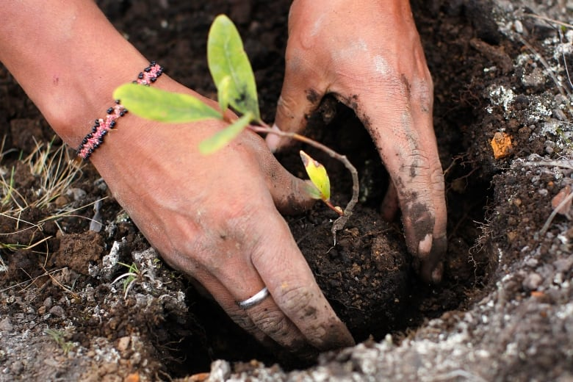
A worker plants seedlings for reforestation at Huayquecha Biological Station near Paucartambo, Cusco. Trees remove more carbon from the air when they are younger, the study authors said. The potential for removing the most carbon is in the tropics. (Enrique Castro-Mendivil/Reuters)
Planting trees is not a substitute for weaning the world off burning oil, coal and gas, the chief cause of global warming, Crowther emphasized.
"None of this works without emissions cuts."
Nor is it easy or realistic to think the world will suddenly go on a tree-planting binge, although many groups have started , Crowther said.
"It's certainly a monumental challenge, which is exactly the scale of the problem of climate change."
As Earth warms, and especially as the tropics dry, tree cover is being lost, he noted.
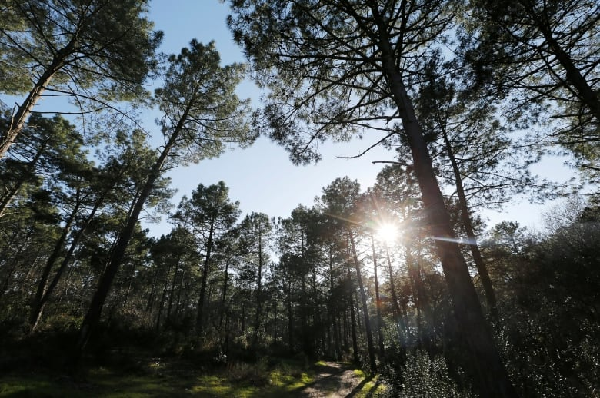
Pine trees are pictured on the International Day of Forests in the Landes forest near Le Pyla, France March 21, 2019. Researchers estimate that even with existing cities and farmland, there's enough space for new trees to cover 9 million square kilometres around the globe or about the area of the United States. (Regis Duvignau/Reuters)
The researchers used Google Earth to see what areas could support more trees, while leaving room for people and crops. Lead author Jean-François Bastin estimated there's space for at least one trillion more trees, but it could be 1.5 trillion. That's on top of the three trillion trees now on Earth, according to earlier Crowther research.
- 'Building back better' and other tips for adapting to climate change

EDITOR'S NOTE
Why CBC News is doing a series on climate change
The study's calculations make sense, said Chris Field, an environmental scientist at Stanford University in California who also wasn't part of the study.
"But the question of whether it is actually feasible to restore this much forest is much more difficult," Field said in an email

https://www.msn.com/en-za/news/world/iguanas-spread-in-florida-as-climate-warms-theyre-a-menace/ar-AADMwLl

Iguanas spread in Florida as climate warms: ‘They’re a menace’

Lori Rozsa

22 hrs ago
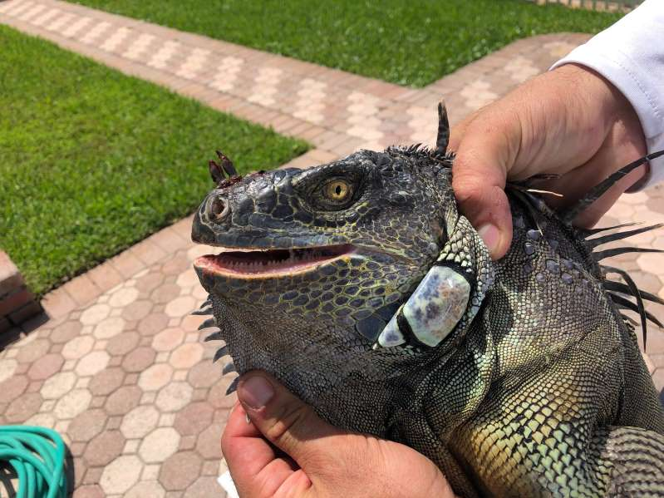An iguana trapped last month at a South Florida home. (Lori Rozsa)
FORT LAUDERDALE — The first time he saw iguanas on his roof last winter, Bob Lugari was enchanted. He had recently moved from California to South Florida, and the bright green lizards seemed to fit right into the subtropical vibe of his new home.
“I thought, how adorable, how cute, how Floridian,” Lugari said. “They looked so tropical. I never had iguanas in California, and I thought, this is part of the Florida experience. I should embrace this.”
Subscribe to the Post Most newsletter: Today’s most popular stories on The Washington Post
But soon Lugari found his carefully cultivated ornamental plants defoliated. He started finding messy brown piles of iguana droppings on his pool deck. He saw several lizards, fattened from months of feasting on his flowers, hanging out around his house and yard.
“They aren’t cute anymore,” Lugari said this month of the animals, which are not native to Florida. “They’re a menace.”
The state of Florida agrees. After a warm winter and now with record-breaking summer heat — the kind of weather iguanas thrive in — the Florida Fish and Wildlife Conservation Commission has declared open season on the exotic reptile.
“The FWC encourages homeowners to kill green iguanas on their own property whenever possible,” the commission recently wrote on its website. “Iguanas can also be killed year-round and without a permit on 22 public lands in south Florida.”
Agency biologists say they don’t know how many iguanas are in Florida, but they know the kinds of problems they’re causing. These include “erosion, degradation of infrastructure such as water control structures, canal banks, sea walls and building foundations,” state biologist Dan Quinn said in an email.
Along with doing damage by digging, iguanas destroy landscaping and ornamental plants, including some that are endangered. They can also carry salmonella.
Green iguanas have been spotted in Florida since the 1960s, but their numbers have soared in recent years. They’re native to Central America, parts of South America and some islands in the eastern Caribbean.
Climate change is helping them spread quickly in South Florida, said Joseph Wasilewski, who has studied green iguanas for 40 years. He’s part of the University of Florida’s “Croc Docs” team of scientists who study wildlife in Florida and the Caribbean.
“Climate change certainly has something to do with it,” Wasilewski said. “It’s warming things up and allowing them to go further north.”
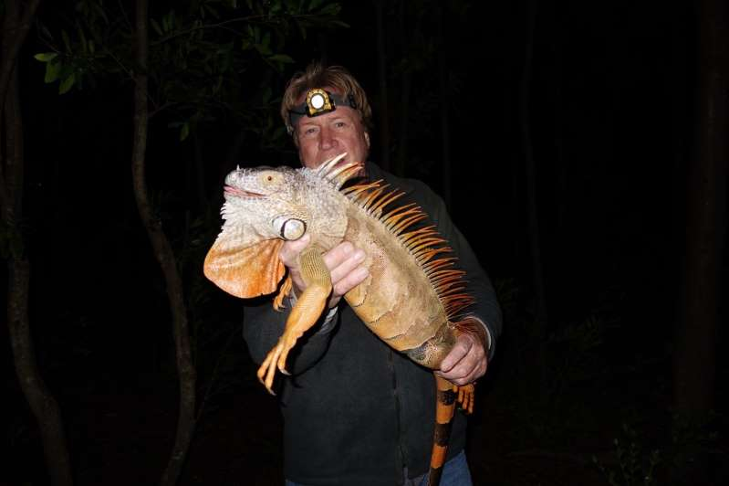© Joseph Wasilewski University of Florida biologist Joseph Wasilewski with a green iguana. "If we don’t so something soon, they could literally take over,” he said.
Florida needs to get a handle on the green iguana invasion before it gets worse, Wasilewski said. He said he saw Grand Cayman island go from having no green iguanas in 2000 to having an estimated 1.6 million in 2018. The island launched a large-scale cull last fall, and nearly 800,000 iguanas have been killed so far.
In Florida, “in the last five or 10 years, I’ve seen the population literally explode,” Wasilewski said.
Green iguanas can grow up to five feet long and weigh around 17 pounds, although local trappers say they’ve seen bigger lizards than that. They live for 10 years or more, and the females can lay six dozen eggs at a time. They dig long tunnels, up to 80 feet — sometimes under sea walls, sometimes under houses and occasionally under highway overpasses.
The state’s call to action has resulted in business opportunities. Blake Wilkins and Perry Colato are co-founders of Redline Iguana Removal. Wilkins, a biologist for Broward County, and Colato, a county firefighter, are childhood buddies who grew up catching the iguanas and turning them into pets.
“They were all named Iggy,” Colato recalled. “We’d catch them by hand. There weren’t that many back then. But they have no natural predators here, and there’s nothing to limit their population.”
Colato and Wilkins started their business in the fall of 2018. They charge $50 to trap one iguana or a flat rate if a homeowner has a multi-iguana problem, which is usually the case. They trapped and removed the iguanas on Lugari’s property in May.
“They’re great swimmers, they’re great climbers, they’re great diggers,” Wilkins said. “They can get on your roof, and they can dig under your house.”
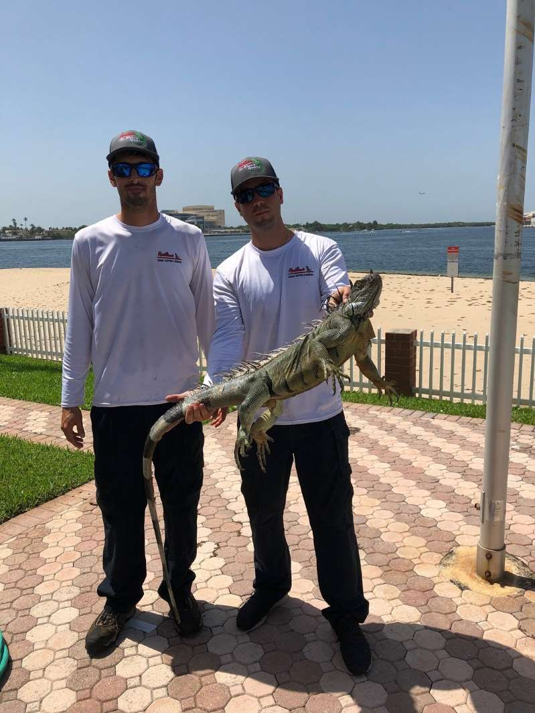Blake Wilkins and Perry Colato, the co-founders of Redline Iguana Removal, with a green iguana they trapped at a South Florida home last month. (Lori Rozsa)
The pair sets traps baited with favorite iguana foods, such as pieces of mango and melon. They said they check the traps frequently and almost always find an iguana. They kill the lizards with a rifle shot and then have them cremated.
Both admit to having mixed feelings about that, but they said they’ve seen firsthand the damage iguanas can do. So has Lugari, who found the animals’ toileting habits to be particularly unpleasant.
“At first, I thought it was mud. I scrubbed the entire area and got it perfectly clean,” Lugari said. “The next morning, the splash marks were back. Then I noticed that they were parallel to the roof line. I looked up, and I saw what they were doing. They were backing themselves up to the edge of the roof, doing their business, splashing it on the tile below and then going back to sunning themselves on my roof.”
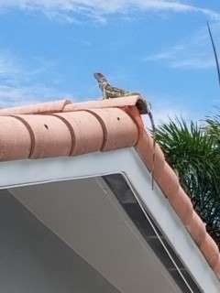© Bob Lugari A green iguana makes itself at home on the roof of Fort Lauderdale, Fla., resident Bob Lugari.
The only natural population control that works with green iguanas is temperature: They don’t like the cold. It’s got to be below 40 degrees for four consecutive days, and that’s very rare in South Florida,” Colato said. “So it’s only gotten worse and worse.” A cold snap two years ago in the state put iguanas into a dormant state, causing frozen iguanas to fall out of trees. They weren’t dead, just deeply chilled. “I had a buddy pick one up and put it in the back of his car,” Colato recalled. “He was going to take it home and eat it, but it thawed out while he was driving and basically came alive. He freaked out and pulled over and opened the door, and it ran away.” Iguanas are a food source in some Caribbean countries, where they’re called “chicken of the trees.” Colato said a friend from Trinidad and Tobago cooked one in a curry. (“It was very good, actually,” he said.) But most Floridians don’t view them as entrees. Trapper Jose Gonzalez started his Palm Beach County-based company, Iguana Police, last year. Business has been brisk, he said.
“The numbers are getting higher, and the iguanas are getting bigger,” Gonzalez said. “I think they’re running out of space south of here, and these waterways in South Florida are the perfect vehicles for them to move up and down the coast.” Like Colato and Wilkins, Gonzalez said he feels a twinge of guilt about shooting the animals. “But they’re a nuisance. They’re really no different than a rat in that sense,” Gonzalez said. “They create damage, they spread disease, and they’re invasive.” With so many iguanas in the firing line, captures occasionally go wrong. Removal services sometimes use air rifles in wide-open areas, such as golf courses and farms, and one trapper’s shot recently went astray in Boca Raton. Homeowner E’Lyn Bryan said she was inside her home when she heard a pool maintenance worker screaming on her patio. “I ran out, and his leg was bleeding,” Bryan said. The worker told authorities that he was doing pool work when he felt his leg burning, the Boca Raton Police Department wrote in an incident report. He said he heard “a lot of popping noises before he got hurt” and “determined it was caused by a BB pellet that was being shot from an iguana hunter a couple of houses down.”
The iguana hunter apologized, and paramedics said the pool man’s injury was superficial, according to the police. The victim did not press charges. The trapper had been hired by the homeowners association, something that infuriated Bryan. “I want the iguana killing stopped,” Bryan said. “These creatures deserve to live. They shot one in the leg, and now it has to get around on three legs. If humans can’t cohabitate with them, there has to be a more humane way to deal with it.” Wasilewski agrees, to a point. “The state has to address the problem,” he said. “I’d suggest homeowners use professional removal services rather than having people go out and start shooting like it’s the wild, wild West. But if we don’t do something soon, they could literally take over.” Lori Rozsa is a freelance reporter and frequent contributor to The Washington Post. She is a former correspondent for People magazine and a former reporter and bureau chief for the Miami Herald.
Read more:

GREEN ECONOMY

BLUE ECONOMY

Cyprus

Cyprus-Ireland Blue Growth Initiative 2019 concludes
By CNA News ServiceJuly 4, 20190 Comments165
SHARE0

The first “Cyprus-Ireland Blue Growth Initiative” which has taken place in Ireland and Cyprus was successfully concluded, the Irish embassy announced. it said that following the visit of Ireland’s Tánaiste (Deputy Prime Minister) and Minister for Foreign Affairs, Simon Coveney to Cyprus in June 2018, it was agreed, with Foreign Minister, Nicos Christodoulides that cooperation should be enhanced between Ireland and Cyprus, as two EU island nations, in the marine and maritime sectors.The first year of the initiative has involved an academic, educational exchange between University College Cork (UCC) in Ireland and AKTI Project and Research Centre, based in Cyprus. The themes explored this year have included microplastics/marine litter, blue growth, marine renewable energy, entrepreneurship within the blue economy, and other marine and maritime-related issues. Following the exchanges, discussions have now commenced on ways to enhance the collaboration between the two countries through the development of Memorandums of Understanding for academic, research, civil society and industry collaboration. Christodoulides had a meeting with Ambassador of Ireland Deirdre Ní Fhallúin, the students from University of Cork in Cyprus and the team from AKTI Project and Research Centre. He said the ‘Cyprus-Ireland Blue Growth Initiative’ “is a prime example of the innovative cooperation we are looking for and that we are therefore happy to encourage and support.” Ní Fhallúin said the aim of the project is to develop bilateral relations between Ireland and Cyprus in two key respects – marine/maritime and higher education.
“As two islands at the opposite sides of Europe, Ireland and Cyprus have much to learn from each other through sharing expertise and learning. The project complements the role being played as consortium members by the Irish Marine Institute and SmartBay Ireland in the development of the Cyprus Marine and Maritime Institute (CMMI) in Larnaca.”Head of AKTI Xenia Loizidou said the two island countries, have so much in common, “limited natural resources and a fragile environment. Sustainability is the only way forward. Cooperation and networking make us stronger and resilient, to protect our islands, to protect our seas, to develop within the Blue framework of growth”
http://www.medblueconomyplatform.org/fr/vkc/news/

Video: Mediterranean Marine Protected Areas as nature-based solutions to CC
Posted on 05/06/2019
Mediterranean Marine Protected Areas (MPAs) have an important role in providing ecosystem services, mitigating the impacts of climate change and increasing ecological and socioeconomic resilience of biodiversity and surrounding coastal communities. Increasing the number of MPAs and developing appropriate management actions within them are essential to maintain the natural resilience of marine habitats against climate change impacts in the Mediterranean. Watch the video produced by IUCN, International Union for Conservation of Nature here: https://www.youtube.com/watch?v=gIytHdaHgVk&feature=youtu.be

International MEDCOAST Congress 2019
Posted on 30/05/2019
The Fourteenth International MEDCOAST Congress on Coastal and Marine Sciences, Engineering, Management and Conservation will be celebrated on 22 - 26 October 2019, in Marmaris, TURKEY. The MEDCOAST congress in Marmaris (Turkey) is the fourteenth event of the biennial series that was started in 1993 for contributing to coastal and marine sciences, engineering, management and conservation particularly in the Mediterranean and the Black Sea. Since the first event in 1993 (Antalya, Turkey), the MEDCOAST congress series have travelled around the (...) Read more.

G7 Marine Litter Workshop Metz: Conclusions and Recommendations
Posted on 30/05/2019
Representatives of G7 Countries, Regional Seas Conventions and Programmes to which G7 Countries are party, and a number of stakeholders from intergovernmental mechanisms, civil society, and industry, met in Metz, France, on 5 and 6 May 2019 on the occasion of the “Workshop on the G7 Action Plan to Combat Marine Litter in Synergy with the Regional Seas Conventions”. The event was organized by the French G7 Presidency and the UN Environment/Mediterranean Action Plan–Barcelona Convention Secretariat, with the generous support (...) Read more.

New EASME Call on MSP: Deadline 04 September 2019
Posted on 14/05/2019
This is an EU call for grants in the area of Maritime Spatial Planning under the European Maritime and Fisheries Fund. This call for proposals is launched in accordance with the 2019 Work Programme for the implementation of the European Maritime and Fisheries Fund (EMFF) (section 1.2.1.8 of the annex to the Work Programme). Specific Challenge: The objective of this call for proposals is to support the establishment and implementation of Maritime Spatial Plans in line with the objectives pursued (...) Read more.

Towards a Blue Revolution: A TNC and Encourage Capital Report
Posted on 09/05/2019
The Nature Conservancy and Encourage Capital have partnered to create a guide to impact investing in sustainable aquaculture, launched today. This guide represents the first-ever attempt to comprehensively assess the potential of sustainable aquaculture through both an environmental and financial perspective. The recently published guide identifies three attractive impact investment opportunities which can help drive more environmentally friendly production, adding up to a rare opportunity for investors to generate compelling financial returns. These are: 1. Seaweed and bivalve systems 2. (...) Read more.

https://reliefweb.int/report/world/caribbean-countries-benefit-access-insurance-fisheries-sector

Grand Cayman, Cayman Islands, July 3, 2019. CCRIF SPC and the World Bank are pleased to announce that on July 1, the Facility issued the Caribbean Oceans and Aquaculture Sustainability FaciliTy (COAST) fisheries parametric insurance policy to two of its member governments – Grenada and Saint Lucia. The COAST insurance policies provide coverage for fisherfolk and other players in the fisheries industry to enable them to recover quickly after weather-related events. Initial funding for COAST has been provided by the U.S. State Department.
The COAST insurance product is another in a list of innovative parametric insurance products that are provided by CCRIF to Caribbean and Central American governments. Since its inception in 2007, CCRIF has been providing insurance for tropical cyclones and earthquakes, and in 2013, based on demand from its members, the Facility provided coverage against excess rainfall events. The addition of the fisheries product reinforces CCRIF’s commitment to meeting the needs of the region. Both Saint Lucia and Grenada recently renewed their tropical cyclone, earthquake and excess rainfall policies for 2019/20.
While it is governments that purchase COAST policies, this parametric insurance product is unique – it incorporates a livelihood protection component (akin to microinsurance) and a tropical cyclone component (sovereign insurance). The COAST product provides coverage for losses caused by “bad weather” on fisherfolk and for direct damages caused by tropical cyclones (wind and storm surge) to fishing vessels, fishing equipment and fishing infrastructure. In this case, “bad weather” is defined as occurrence of high waves and heavy rainfall throughout the policy year. The Caribbean is the first region globally to develop and implement parametric climate risk insurance for the fisheries sector. For the first time, vulnerable fishing communities will have access to insurance developed specifically for their needs, protecting their livelihoods and playing a key role in closing the protection gap.
Like CCRIF’s other parametric insurance products, COAST insurance also is parametric, whereby payouts are made based on a pre-defined level of wave height, rainfall, wind or storm surge and their impact. Therefore, payouts can be made quickly – within 14 days of the event to honour one of CCRIF’s core principles. If a country’s policy is triggered, the funds will be provided by CCRIF to the Ministry of Finance, followed by a rapid transfer to the fisherfolk and other affected parties throughout the country’s fishing industry. To facilitate timely transfer of funds, the list of beneficiaries is defined at the time of policy inception by the government and is designed to include beneficiaries from the fisheries value chain, including fishers, crew members, captains, boat owners, fish vendors and processors, etc.
Through identification of the beneficiaries and predefined procedures for payout transfers, COAST will allow for tracking the flow of funds down to the level of the beneficiaries, with a financial management and auditing system in place. These detailed data will support beneficiary analyses in the region. For example, CCRIF recently estimated that over 2.5 million persons in the region have benefitted from 38 payouts totalling US$139 million to 13 of its 21 member countries since 2007. COAST has been developed with the support of the U.S. State Department, and has been led by the World Bank and CCRIF. In addition, the Caribbean Regional Fisheries Mechanism (CRFM) has played an essential role, as benefitting countries must be implementing the Caribbean Community Common Fisheries Policy (CCCFP). This linkage signals the beginning of a new partnership between CCRIF and CRFM, which signed an MOU in April to focus on the implementation of the COAST initiative and promotion of climate-resilient and sustainable fishing, fish farming and resource management practices in the region.
Indeed, the COAST insurance product for the ﬁsheries sector is an innovative climate risk insurance mechanism and will be an essential tool to help address the impacts of natural hazards on food security and livelihoods of those working in the ﬁsheries sector. The World Bank has played a major role in the development of this product to ensure that it promotes resilience in the fisheries sector and contributes to the sustainable management of the ecosystems that support the sector by incentivizing policy reforms for the uptake of climate-smart fisheries practices and increasing coastal resilience. This will help to build a stronger foundation for advancing the blue economy, while supporting the livelihoods of those who depend on the valuable marine resource.
The project partners congratulate the Governments of Grenada and Saint Lucia on their pioneering role in using this ground-breaking insurance product to protect stakeholders in an industry that is an important contributor to food security and GDP. CCRIF plans to roll out the COAST product to other countries that may be interested.
About CCRIF SPC: CCRIF SPC is a segregated portfolio company, owned, operated and registered in the Caribbean. It limits the financial impact of catastrophic hurricanes, earthquakes and excess rainfall events to Caribbean and – since 2015 – Central American governments by quickly providing short-term liquidity when a parametric insurance policy is triggered. It is the world’s first regional fund utilizing parametric insurance, giving member governments the unique opportunity to purchase earthquake, hurricane and excess rainfall catastrophe coverage with lowest-possible pricing. CCRIF was developed under the technical leadership of the World Bank and with a grant from the Government of Japan. It was capitalized through contributions to a Multi-Donor Trust Fund (MDTF) by the Government of Canada, the European Union, the World Bank, the governments of the UK and France, the Caribbean Development Bank and the governments of Ireland and Bermuda, as well as through membership fees paid by participating governments. In 2014, an MDTF was established by the World Bank to support the development of CCRIF SPC’s new products for current and potential members, and facilitate the entry for Central American countries and additional Caribbean countries. The MDTF currently channels funds from various donors, including: Canada, through Global Affairs Canada; the United States, through the Department of the Treasury; the European Union, through the European Commission, and Germany, through the Federal Ministry for Economic Cooperation and Development and KfW, and Ireland. In 2017, the Caribbean Development Bank, with resources provided by Mexico, approved a grant to CCRIF SPC to provide enhanced insurance coverage to the Bank’s Borrowing Member Countries.

Ongoing

Primary country
World

Other countries
- Grenada
- Saint Lucia

Content Format:
  - News and Press Release

Language:
  - English

Theme:
  - Agriculture
  - Disaster Management

https://www.fbcnews.com.fj/news/government-looking-at-issuing-blue-bond-to-protect-marine-resources/

vernment looking at issuing blue bond to protect marine resources
Praneeta PrakashMultimedia Journalistpraneeta.prakash@fbc.com.fj | @PraneetaFBCNews

JUNE 10, 2019 6:50 AM
With rising threats to ocean and marine resources, the government is now looking at the issuance of blue bonds.Blue Bond is a financing initiative which taps into capital markets to fund ocean-related environmental projects.During the budget announcement, Minister for Economy Aiyaz-Sayed-Khaiyum highlighted that Fiji will be adopting more blue and ocean-friendly policies in the next financial year.
“We will also be pursuing the issuance of blue bond to fund these critical efforts to preserve our oceans and build a blue Fiji. In earlier discussions we have already sparked strong initial interest in the bond among our developing partners and we will have more details on this initiative in the months to come.”
The Minister says discussion with developing partners on the issue continues.
“This focus on cultivating a sustainable blue economy will take close coordination efforts across government, businesses, our developing partners and society, particularly to benefit those many Fijians who have long relied on our oceans for their likelihoods.”
Fijians are being urged to also participate in the government’s effort to build a blue economy from the grassroots level by planting mangroves and cleaning up rubbish from the beaches.

Africa needs to manage its blue economy for a sustainable future
By David Kaye on July 3, 2019

Credit: iStock/Lou Armor
The prospect of a fully sustainable blue economy for Africa gathered significant momentum following the second Africa Blue Economy Forum (ABEF) held in Tunis recently. Fishing, aquaculture, shipping, ports, energy and finance industries all came under the spotlight, with speakers stressing the need for direct action to deliver the environmental, economic and social benefits for Africa. Speakers agreed on the…
https://www.commercialriskonline.com/africa-needs-to-manage-its-blue-economy-for-a-sustainable-future/

Africa’s Blue Economy is a vehicle for sustainable development.
June 07, 2019
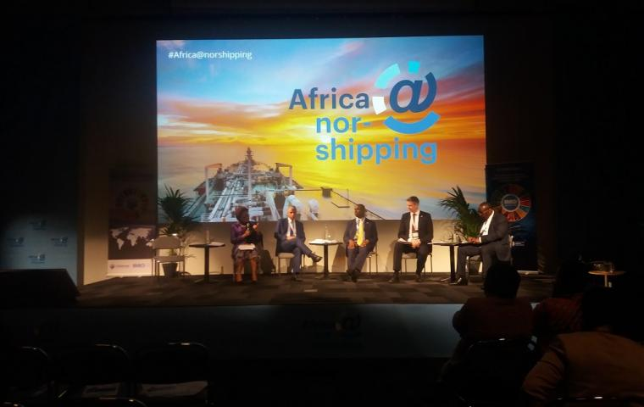
Oslo, Norway, 7 June 2019; In Africa, 38 of 54 African states are coastal states with over 90% of Africa’s imports and exports transported by sea, making the continent a strategic gateway for international trade. The continent’s geopolitical importance and of sound ocean governance is therefore of significant prominence to the African Union.
At the Africa@Nor-Shipping 2019 conference held under the theme “Unleashing the potential of Africa’s Blue Economy”, the African Union Commission reiterated the need to create an enabling framework for the development of Africa’s blue economy while ensuring environmental and economic sustainability and improving maritime safety and security in Africa’s waters.
The Vice President of Seychelles. H.E. Vincent Emmanuel Angelin Meriton, noted that maritime shipping is the lifeblood of Africa, however observing that despite significant opportunities the sector holds, Africa still makes up a small percentage of global trade. He underscored the need for the continent to advantage of the economic potential of its ports and shipping sector if it is to realize its growth ambitions. “If we are to truly unlock Africa’s potentials we must acknowledge that despite the successes, Africa is still facing numerous 12 challenges in developing the Blue Economy agenda. These range from financial barriers to limited access to technology, and they are preventing some states to fully implement their plans”, he stated with optimism that challenges can be addressed through mutual partnerships and cooperation.
The President of the Republic of Seychelles H.E Mr. Danny Faure was in 2018, nominated as the AU Champion for Blue Economy to advance the Blue Economy agenda at the national and continental level.
While some challenges that threaten the sustainable use of oceans and sea resources such as marine plastic, litter and micro-plastics, biodiversity loss and climate change still persist, the African Union Commission Commissioner for Rural Economy and Agriculture (DREA) H.E. Josefa Sacko, however highlighted the encouraging efforts, particularly in Africa, in addressing the plastic pollution and waste management. “We are pleased that a growing number of countries are banning the use and sale of plastic bags. This complements the campaign launched by AU Commission earlier this year to reduce plastic pollution”, she stated. The campaign identified five first ladies to serve as regional champions for the Campaign. The Commissioner restated AU’s commitment to support efforts for a sustainable Blue Economy to harness its full potential as a vehicle economic development and growth through creation of jobs and reduction of poverty.
With the climate change, the coastal systems are sensitive to changes in sea level, ocean temperature and ocean acidification exposing Africa’s six small island states and a coastline to extreme weather, increased vulnerability of communities and loss of biodiversity. To address the threats of climate change to the Blue Economy, the AU Commission is in the process of finalizing a continental strategy on climate change to respond to the impacts of climate change. The strategy will contain a section on addressing climate impacts on oceans, the ecosystems and biodiversity. The Commission is also engaged in the Africa Region Consultative process for the Post 2020 Global Framework for Biodiversity.
Minister of Foreign Affairs of Norway, H.E. Ine Eriksen Soreide, on her part, observed that while challenges of poverty, pollution and climate change remain, mutual collaboration is the key to unleash the tremendous potential of the ocean supported by the technological advancement. “We cannot just ask what the ocean can do for us, but also what we can do for the ocean. Instead of worrying what the transition to a greener future is going to cost, many of you have proven that green technology does not lead to red numbers in the account book”, she stated.
At the margins of the conference, the AU delegation also held bilateral meetings with the Minister of Foreign Affairs of Norway, Representatives of the AU Key private sector and institution partners including the Association of Africa Maritime Administrators (AAMA), the International Maritime Organisation (IMO), the Association of Women in Maritime in Africa (WIMAfrica) and the African of Shipowners Association (ASA) to deliberate on the new perspective of the Commission regarding Africa’s Blue Economy and the importance of collaborative partnerships. The Commissioner was accompanied by Amb. Dr. Namira Negm, AU Legal Counsel and Amb. Rossette Nyirinkindi, Technical Advisor to the Chairperson of the AU Commission on Regional Integration.
For further information, please contact:
Mrs. Christiane Yanrou-Matondo, Principal Communication Officer, Bureau of the Chairperson; E-mail: Yanrouc@africa-union.org.
Mr. Molalet Tsedeke, Media Center Coordinator; Directorate of Information and Communication; AU Commission. molalett@africa-union.org ; Tel: 0911 630631.
Directorate of Information and Communication, African Union Commission, DIC@africa-union.org, www.au.int, Addis Ababa, Ethiopia.

Africa’s Small-Scale Fisheries Critical to Food Security

Content provided by
03/07 - 13:35
Africa’s small-scale fisheries play a critical role in global food security and must be supported with greater research and investment, say international and African experts.

Industry, NGO, government and academic representatives attended Murdoch University’s second Blue Economy Symposium in Tunis last week as part of the Africa Blue Economy Forum (ABEF) 2019 and Murdoch University’s Third Commission, a research investigation focusing on issues of public concern to Africa.

Fish accounts for more than one-fifth of the protein intake of African south of the Sahara and provides a livelihood to millions of people.

Murdoch University Adjunct Professor, Dr. Jeremy Prince, who attended the symposium and is contributing to the work the Third Commission in this area, said the collective value of the small scale fisheries of Africa was too big to ignore.

“It is critical that we stabilise and rebuild these fisheries to ensure both food security and the future of the blue economy,” Dr Prince said. “The time to act is now.”

Discussions at the Tunis symposium provided useful insights and contributions to the fine-tuning of the focus and narrative of the Blue Economy chapter of the Third Commission’s report. A strong emphasis was placed on the need to highlight clear and innovative actions to effect lasting transformation of the blue economy in Africa.

Participants in the symposium called on all nations and international institutions to recognise the value and economic impact of small-scale fisheries in Africa. Their recommendations included:

Increasing investment to allow fishing communities to be more involved in the co-management of fisheries; and
Directly engaging with fishing communities to collect and share relevant data regarding the state and economic value of small-scale coastal fisheries.
About the Third Commission

In keeping with Murdoch University’s commitment to quality research and teaching in public policy at both the national and international levels, Murdoch Commissions are exercises in applied public policy informed by rigorous scholarly research and analytical thinking. They bring together senior practitioners, international experts and thought leaders from Australia and around the world to work on pressing problems and issues of public concern.

The first Murdoch Commission, “Western Australia and the evolving regional order: challenges and opportunities” published its final report in November 2013 and the second Murdoch Commission, “Food security, trade and partnerships: Towards resilient regional food systems in Asia” released its report in December 2015.

Murdoch’s Third Commission commenced in June of 2018 and is focused on six themes firmly rooted in the agenda for action identified by the Africa Progress Panel (APP) as being in need of more significant research attention, bolder policy innovation, faster implementation on the ground, enhanced political leadership and the conceptualisation and roll out of innovative research solutions.

These themes are:

Promoting Equity in the Extractive Industries: Managing the Extractives Industry in a more equitable, transformative and sustainable;
Boosting the Blue Economy: Better Monitoring, Governing and Harnessing of the Blue Economy;
Promoting Sustainable Agriculture and Food Production: Enhancing Sustainable Farming and Food Production and Nutritional Security;
Increasing Power and Light: Creating greater and more innovative access to Modern Energy (Electricity and Light) Fast; and
Cross-cutting themes of Women & Youth and Climate Change.
An overarching focus of the Third Commission is identifying small scale policy interventions that have potential to make big impacts. Additionally, it seeks to enhance Murdoch University’s links with Africa in areas of the university’s comparative advantage, including research and innovation expertise, strategic interest and networking capabilities within Australia, in Africa and globally.

The Third Commission report is due to be published in 2020.

Distributed by APO Group on behalf of Murdoch University.
Media Contact:

https://www.dw.com/en/what-is-the-blue-economy/av-49188394

https://thefishsite.com/articles/aquaculture-to-take-centre-stage-at-ocean-economy-conference

https://www.cbn.co.za/featured/why-africas-blue-economy-is-one-of-its-biggest-opportunities/

https://www.esi-africa.com/industry-sectors/business-and-markets/africa-pledges-to-deliver-a-sustainable-blue-economy/

Africa pledges to deliver a sustainable Blue Economy
June 28, 2019 0
Blue Economy
The prospect of a fully sustainable Blue Economy for Africa gathered significant momentum following the second Africa Blue Economy Forum (ABEF2019) held in Tunisia’s capital city earlier this week.

Fishing, aquaculture, shipping, ports, energy and finance industries all came under the spotlight at ABEF2019, which drew in all relevant stakeholders from across the globe.

The forum acknowledged the need for direct action to deliver the environmental, economic and social benefits for Africa, and particularly its coastal nations given 90% of Africa's trade is conducted by sea.

Also read: Why Africa needs a Circular Economy framework

Speakers agreed on the urgent need for better cooperation between the ocean stakeholders, better governance and law enforcement.

Regional, national and local strategies are required to build a long-term plan and develop partnerships that are beyond short-term projects.

Engaging with new technologies and innovative financing mechanisms are also key to shaping a sustainable Blue Economy in Africa. Leila Ben Hassen, ABEF founder and CEO of Blue Jay Communication, said: "We can no longer just dip our toe in the water, we must dive in and be decisive in making and delivering change that will serve Africa for many years to come. It is no longer business as usual. Africa must have a sustainable Blue Business plan which will have a positive impact on the environment, on the economy and on society." A sustainable Blue Business plan will accelerate Africa's transformation, create jobs, sustain livelihoods and empower communities, while offering impactful climate change measures. This was acknowledged at ABEF2019 across a range of panels with topics that explored how governments and private sectors can collaborate; tackling ocean pollution; innovative funding solutions; enhanced food security and sustainable growth for the fishing industry; sustainable ocean energy; how to engage more women to work in the maritime value chains and the opportunities to embrace the youth generation in the Blue Economy.

https://neweralive.na/posts/fisheries-ministry-focusses-on-sustainable-blue-economy-policy

Home \ Business \ Fisheries ministry focusses on Sustainable Blue Economy Policy

Fisheries ministry focusses on Sustainable Blue Economy Policy
STAFF REPORTER BUSINESS KHOMAS
2019-06-26 10:33:56 9 days ago

1,341

0

LOGIN / REGISTER TO SAVE

Share on social media

Maihapa Ndjavera
WINDHOEK – Ministry of Fisheries and Marine Resources last week held a consultative workshop on Namibia’s Sustainable Blue Economy Policy development that took place in Windhoek. The same exercise also took part in Walvis Bay during the course of last week.
The Blue Economy is defined as a concept that ensures sustainable and integrated development of the ocean economy. It seeks to ensure that there is environmental sustainability, social and economic inclusivity, and a sustainable economic development approach to all marine activities in the country. Blue economy differs from ocean economy in that it must include the three pillars of blue economy in order to be considered blue, namely environmental sustainability, economic sustainability and social inclusion.
According to Minister of Fisheries and Marine Resources, Bernhard Esau, the Blue Economy is the utilisation of ocean resources in a manner that sustains the overall ocean base.
The process of formulating Namibia’s Blue Economy policy has been outlined in the fifth National Development Plan (NDP 5) and thus the recent workshop was a crucial first step to achieving this national goal.
Participants at the workshop applauded the inter-ministerial committee comprised of nine ministries (Fisheries and Marine Resources, International Relations and Cooperation, Land Reform, Mines and Energy, Environment and Tourism, National Planning Commission, Works and Transport, Industrialisation, Trade and SME Development and the Office of the Attorney General), for their efforts and achievements of the blue economy policy formulation road-map to date.
The Blue Economy in Namibia includes fisheries, marine mining, marine and coastal tourism, maritime transport and coastal infrastructure such as ports, towns and coastal industries.
Esau noted that a marine business cannot be considered blue economy if it does not minimise its negative impacts on the environment, does not have an inclusive ownership structure, and does not maximise creation of jobs.
“I would like to extend a special invitation to all Namibians, either individually or organisations such as private sector/industry organisations in our marine economy, non-governmental organisations, inter-governmental organisations, who are in one way or another seized with sustainability issues in the marine or any other aquatic systems, to come forward and participate in this process either through the workshops, or by making written submissions to the secretariat,” concluded Esau.
Staff Reporter
2019-06-26 10:33:56 9 days ago

ENHANCE THE COMPETIVENESS OF CYPRUS & EU BLUE ECONOMY

CREATE A CRITICAL MASS OF INFRASTRUCTURE AND HUMAN CAPITAL IN THE REGION
prev
next

MARITEC-X

Update: MaRITeC-X project has been awarded with the WIDESPREAD-01-2018-2019 Teaming Phase 2 Grant.
Join our event to discover our plan for the CMMI (July 16, 2019)
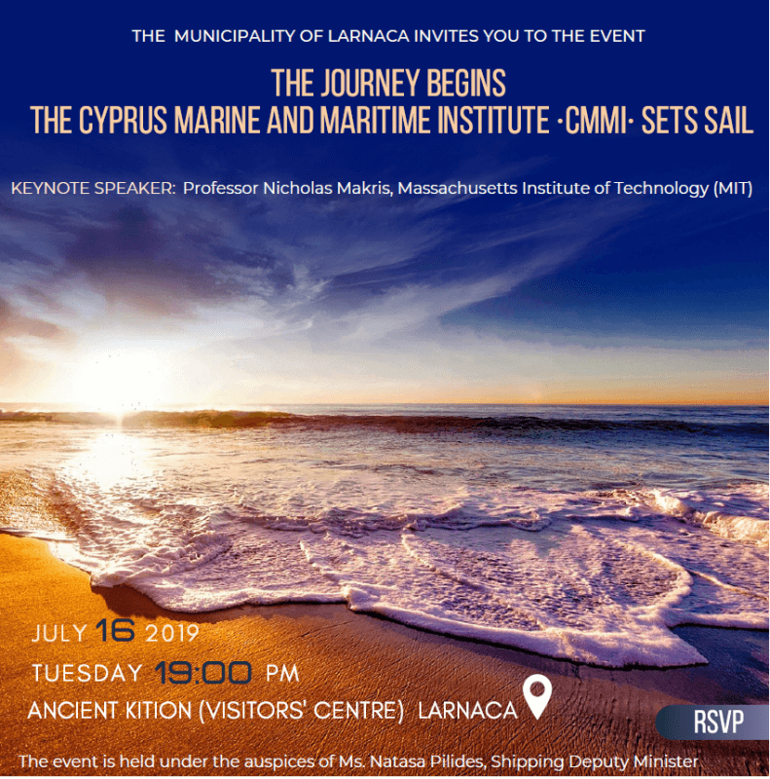
Our project to establish in Cyprus the Marine and Maritime Institute kicks-off October 2019.
The vision of MaRITeC-X project is to establish the Cyprus Marine and Maritime Institute – CMMI. Our own Marine and Maritime Research Innovation and Technology Centre of Excellence to act as an enabler of scientific and business excellence in – the crucial for our island – Marine and Maritime sectors, including the – rabidly emerging – Offshore sector; and will be aligned to the overall Smart Specialization Strategy for Cyprus (S³Cy) and the European priorities on specific pillars with competitive advantages to the Cypriot economy.
Focusing on key priority sectors such as maritime transport, offshore energy, maritime and coastal tourism and aquaculture, the CMMI will forge partnering relationships with well-known European institutions and businesses, active in the fields of research, technology and innovation for the Blue Economy, thus contributing to the transfer of knowledge, the development, application and dissemination of cutting-edge technologies, the exchange of best practices and the development of a critical mass of infrastructure and human capital in the Eastern Mediterranean region.
Download the MaRITeC-X Briefing Note and find more on our plan to establish the CMMI.
https://bvinews.com/marine-survey-being-done-to-develop-bvis-blue-economy/
A two-week marine survey is currently being undertaken to assist government with making informed decisions in developing a blue economy for the BVI.
Speaking at a media conference on Wednesday, Natural Resource Minister Vincent Wheatley said this measure is a step in the right direction for the territory.
“This survey is going to inform how best to use these waters going forward … Everyone would say ‘let’s go ban the catching of turtles’. But there is actually no evidence for this to suggest what we should do with turtles. It also extends to November which is Lobster Fest. Persons would say ‘ban the catching of lobsters — you’re catching too many lobsters’ but there is no evidence to suggest that. This exercise is going to help us inform those kinds of decisions as far as our environment is concerned,” the minister said.
He added: “There are also lots of things like ghost traps on the ocean bottom that are killing fish after fish. This survey is going to help us find some, if not all of them so we can make a decision on what is the best material to make traps from.”
Wheatley further said government is trying to move to an ‘exclusive economic zone’.
He did not expound on what an exclusive economic zone means but said, “to get that category, you must know what it is you are going to manage and explore and you must demonstrate the capacity to monitor and control that space. Something as simple as shipwrecks, there are dozens of shipwrecks around here which can be used for commercial purposes once you know where they are, the depth of water, what’s in and around them and so forth.”
In the meantime, it is said the ongoing survey will be able to provide actual maps of the underwater habitats that comprise the Virgin Islands.
The marine survey is a partnership between the Foreign and Commonwealth Office (FCO) which provided the funding in the sum of $145,000, the Recovery and Development Agency which is responsible for managing the funds, the National Oceanography Centre, and the Ministry of Natural Resource and Labour.
The survey ends on Friday July 5.
https://www.kbc.co.ke/state-maritime-training-blue-economy/
https://yourstory.com/2019/07/budget-2019-nirmala-sitharaman-five-trillion-dollar-economy
The Union Budget for 2019-2020 was a path breaker for many reasons - with India’s first full-time woman Finance Minister Nirmala Sitharaman discarding the signature leather briefcase in favour of a “bahi-khata” (a ledger). But, most importantly, it has laid down a vision for the country in the years to come.

“The Indian economy will grow to become a $3 trillion economy in the current year. It is now the sixth-largest in the world. Five years ago, it was at the 11th position. In Purchasing Power Parity terms, we are, in fact, the third-largest economy already, only next to China and the US,” said Nirmala Sitharaman in her maiden Budget speech.

The Economic Survey of 2018-19 presented the blueprint to turn the country into a $5 trillion economy by 2024-25. If this target is achieved, it would be a creditable achievement, considering the nation was the size of $1.85 trillion in 2014.

Also Read

Budget 2019: Relief for startups as govt eases Angel Tax regulations

The first Union Budget of the Prime Minister Narendra Modi’s second term touched all aspects of the economy, from fiscal health, creation of infrastructure, meeting the needs of the common citizens, education, environmentally sustainable policies, and making India an attractive destination for overseas investments.

If connectivity acts as the crucial glue that will ensure an all-round development across the country, then Sitharaman did not disappoint. She said, “To take connectivity infrastructure to the next level, we will build on the successful model in ensuring power connectivity – One Nation, One Grid – that has ensured power availability to States at affordable rates. I propose to make available a blueprint this year for developing gas grids, water grids, i-ways, and regional airports.”

The Union Budget has clearly set out the plan of creating a blue economy, which will focus on all these sectors.

The startup ecosystem received the well-deserved praise from the Finance Minister. These were not just empty words as the dreaded Angel Tax was put to rest for the segment. Sitharaman was very clear that startups and investors will not come under the purview of Angel Tax and adequate safeguards are being ensured that there is no repeat of the past.

Avnish Sabharwal, Managing Director – Accenture Ventures and Open Innovation, India and Middle-East, said, “The Union Budget 2019 has promised a major boost to the startup ecosystem in India. The proposed Angel Tax simplification is an encouraging move. We believe Indian startups will be able to raise a higher amount of risk capital from investors, and e-verification will lead to a higher number of angel investors funding in Indian startups. We will also see a higher number of startups operating in India, registering themselves in the country, instead of abroad. These steps will surely enhance India’s ranking on the Ease of Doing Business Index and the Global Innovation Index.”

One of the key differentiating factors of the Budget was that there wasn’t a slew of proposals on the taxation front - either in the form of new taxes or reduction of existing rates. Except that the those in the high-income bracket of Rs 1 crore and above will have to pay a little more tax.

Although, prices of diesel and petrol will be marginally higher with a cess of one rupee, there was no other reason to worry.

Industry body Nasscom, in its reaction to the Union Budget, said, ““The Budget presented today sets the right vision for the envisioned road map to achieve the $5 trillion economy goal. However, it needs to provide the next steps in details for the realisation of the vision. One of the key asks from Nasscom was towards building skills for new-age technologies, which we believe is critical for our success in the Digital Era. The government’s intent to enhance digital skills is a huge step in a positive direction. We applaud the government for recognising this as the need of the hour, and committing to train 10 million young professionals in emerging fields like artificial intelligence, internet-of-things, big data, robotics, and 3D printing.”

(Edited by Saheli Sen Gupta)

https://www.kbc.co.ke/kenya-somali-maritime-dispute-threatens-lamus-blue-economy-prospects/
https://www.miningmx.com/news/markets/37466-greenpeace-calls-for-immediate-moratorium-on-deep-sea-mining/

Greenpeace calls for immediate moratorium on deep sea mining
By
David McKay
-
July 3, 2019

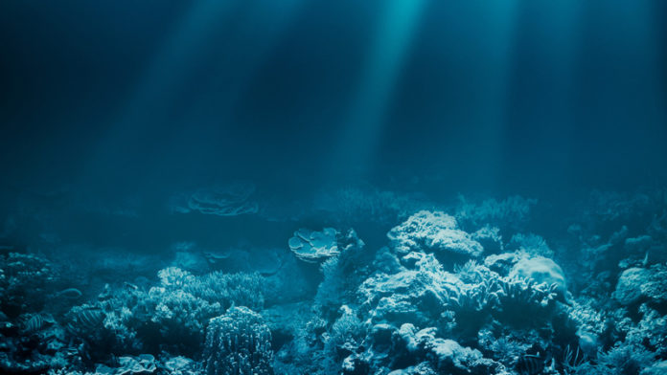

GREENPEACE has called for an immediate moratorium on all deep-sea mining for fear of severe and irreversible harm it may do to the oceans, said BusinessLive citing a report by the activist organisation titled In Deep Water.
In its report, Greenpeace calls for the reprieve and tighter environmental safeguards against the risks of deep sea mining. Although the deep sea is not being mined yet, interest in doing so is mounting fast, said BusinessLive.
Desired resources include cobalt, copper, manganese and lithium for which demand is projected to grow given their key use in the manufacturing of a number of new technologies.
The agency responsible for regulating deep-sea mining — the International Seabed Authority (ISA), which was formed under a UN convention in 1994 — has issued 29 exploration leases covering 1-million square kilometres of the international sea floor. The leases have been granted to sponsoring states — including China, the UK, South Korea, Russia, Germany and India — that work with corporate contractors, and have now laid claim to vast areas of the Pacific, Atlantic and Indian oceans. No such leases pertain to the South African government or the high seas near South Africa, but in May the Department of International Relations and Co-operation hosted a workshop on deep sea mining to promote the sustainable development of Africa’s deep seabed resources in support of the continent’s “blue economy”, said BusinessLive.
https://barbadostoday.bb/2019/06/15/children-learn-the-benefits-of-the-blue-economy/
https://www.defenceweb.co.za/featured/new-marine-protected-areas-need-patrolling-iss/
he recent gazetting of 20 new marine protected areas (MPAs) in terms of South Africa’s Operation Phakisa to develop the blue economy is welcoming and at the same time puts a bigger obligation on maritime and maritime resource protection.
Timothy Walker, a senior researcher at the Pretoria-headquartered Institute for Security Studies (ISS) who specialises in the blue economy both nationally and continentally, said the Ministerial announcement was “gratifying”.
The announcement by Barbara Creecy, recently appointed Minister of Environmental Affairs with the forestry and fisheries portfolios added to her responsibilities, indicated the additional MPAs would increase South Africa’s marine ecosystem area under protection in the country’s exclusive economic zone (EEZ), from the current 0.4% to 5.4%, to provide protection to 90% of habitat types.
Walker pointed out the 5.4% area “slightly exceeded” the target set by Operation Phakisa, the initiative to boost South Africa’s blue economy launched six years ago.
“What is needed is continued protection and monitoring. This increases the obligation of the SA Navy and the new Department of Environmental Affairs which includes forestry and fisheries to patrol and ensure these areas contribute both in terms of sustainability and resilience,” he said, adding the OCIMS (the national oceans and coastal information management system) will be “a great tool” in ensuring this happens. The SA Navy currently only has two dedicated offshore patrol vessels (OPVs) in the fleet with three under construction. Other naval assets, including the Valour Class frigates, Heroine Class submarines, hydrographic vessel SAS Protea and the supply SAS Drakensberg have and will, in all probability, continue with patrol taskings. At the core of operation Phakisa are marine transport and manufacturing; offshore oil and gas exploration; aquaculture; marine protection and ocean governance; small harbours and coastal and marine tourism. Welcoming the new MPA network, Creecy said it was a product of a product of extensive consultation and negotiation with all stakeholders, ensuring it is aligned with relevant policies and priorities for fisheries, aquaculture, tourism, as well as marine mining and oil exploration and protection of ecologically important areas.

https://allafrica.com/stories/201906120145.html

Nigeria: 'Why Nigeria Needs to Optimise the Blue Economy Agenda'
Tagged:

By Sulaimon Salau
Like most great maritime nations, all hands need to be on deck to support Federal Government's efforts in taping into the blue economy, and developing it to such a level that it can contribute far more than currently as projected.
These were the words of the Director-General, Nigerian Maritime Administration and Safety Agency (NIMASA), Dr Dakuku Peterside, at the celebration of the World Oceans Day, on June 8, with the United Nations focus on Gender and Ocean for this year. Peterside, in his message to commemorate the day said Nigeria's ocean resources are rich enough to sustain the economy, like most countries with similar endowment.
He also charged stakeholders on the need to celebrate the ocean, its importance, and on how economic diversification can be achieved for sustainable growth and development. He noted that like virtual reality, which has reduced the real world to a global village, the ocean is global and connects people worldwide, thus inspiring continuing action year-round, to protect and restore this amazing resource that they all depend on.
He further observed that nations like Singapore, the Philippines, and Malta, along with the world great economies like the United States, United Kingdom, Japan, Russia, and China and a host of others, prosper greatly on their oceans as the bedrock of their economy. As such, with about 90 per cent of world trade being done by sea and shipping, it is time Nigeria joined the league of such great countries by engaging its waters more profitably.
"The World Oceans Day celebration inspires the thinking that recognises that there is one global ocean that connects the entire world. Within this one ocean, there are five distinct oceans: the Pacific Ocean, Atlantic Ocean, Indian Ocean, Arctic Ocean, and Southern Ocean. And it is already happening that the boundaries of these oceans are invincible, and so it is important that we take steps to ensure that we tap the abundant resources inherent within our maritime endowment because our lives as a nation depends hugely on it," he said. Noting that climate change, and marine environment degradation are a concern to Nigeria and the international community, Peterside assured that NIMASA will continue to lend its voice in support of the advocacy and drive, which will further guarantee and complement government's ease of doing business initiatives.He reiterated that the Agency is open to all forms of partnerships that can help the growth and development of the Nigerian maritime sector, in line with the government's economic diversification agenda. Meanwhile, the United Nations Educational, Scientific and Cultural Organisation (UNESCO), noted that: "The health of the ocean is in decline. Marine biodiversity is becoming increasingly degraded. In this context, the United Nations has made ocean protection a priority."

https://www.forbes.com/sites/natalieparletta/2019/06/21/making-the-blue-economy-a-sustainable-reality/

Maritime Clusters Are Making The Blue Economy A Sustainable Reality

As industries increasingly turn to the seas for income, developing sustainable blue economies is imperative.
IAN WOOLCOCK, ADOBE PHOTO STOCK
“Blue Economy” has become a popular buzz word over the past decade. Drawing from the notion of a “Green Economy”, it refers to the control of the Earth’s oceans and marine life. But the concept of a blue economy has different, and often conflicting, meanings for different people, resulting in incompatible or blurred definitions and applications.
The conflicts revolve mainly around a drive to make profits from the sea – largely through emerging and traditional large-scale industrial developments – versus environmental sustainability and local community needs.
People are turning to the oceans as terrestrial reserves become depleted. But this precious resource is also suffering the effects of human activities, including climate change, acidification, overfishing, pollution and much more.
Covering two-thirds of the Earth’s surface, oceans are vital for planetary and human health. Not only do they help to buffer the impacts of climate change, these delicate ecosystems also provide habitats for millions of species, more than half the oxygen we breathe and food for more than a billion people.
Essentially, our survival depends on healthy seas.
The ideal model of a blue economy, therefore, is built around “triple bottom line” decision making, integrating economic, social and environmental needs for optimal benefits all round. With a holistic definition in place, the next step is to make it a tangible reality.
A large team of researchers around the South Coast of New South Wales (NSW) in Australia is one emerging cluster that is exploring ways to put the theory of a sustainable blue economy into practice.
It aims to “tap into the excitement and general buzz around the concept, but think about its application in a way that really taps into some of those core values of community engagement, social equity, and of course, environmental protection and maintaining ecological integrity,” explains project leader Michelle Voyer, a research fellow at the Australian National Centre for Ocean Resources and Security.

Aerial views of the Durras inlet on the South Coast of New South Wales, Australia.
LEAH-ANNE THOMPSON, ADOBE PHOTO STOCK
More than 20 academics have come together for the project under the University of Wollongong’s Global Challenges Program, coming from disciplines as diverse as marine biology, arts and humanities, social sciences, engineering and law.
This might sound bigger than Ben-Hur. “That’s very much part of the challenge,” says Voyer. “In ocean-based management, we tend to think about things in silos. The people who look at shipping look at shipping, people who look at fisheries look at fisheries and same for all the other sectors.
“The blue economy is big picture, and it is thinking about, across all these different sectors, how do we think about their management in a more integrated way?”
To illustrate, Voyer describes some work she did with a colleague involved in nutrition and food security in Timor to explore possible opportunities. The region could, for example, draw on their resources to grow export-based fisheries, or build their international tourism markets. How would these activities impact local food security?
“Some of these crossovers are really interesting to pull apart and to get a sense of, who wins and who loses in all these different scenarios that the blue economy might encourage or facilitate,” she explains.
Since the global challenges project’s inception about two years ago, the team developed a stakeholder working group following a large forum that included industry and government representatives, as well as local Indigenous communities, to nut out where to go with the concept.

Eugène VON GUÉRARD, View of Lake Illawarra with distant mountains of Kiama, South Coast of NSW, Collection Wollongong Art Gallery, The George and Nerissa Johnson Memorial Bequest.
MICHELLE VOYER
Linking to maritime industries across the globe, Voyer has also worked with the World Ocean Council, an international collaboration that brings together scientific and industry leaders to advance the UN’s Sustainable Development Goals in ocean development.
As part of her involvement, she compiled a reportderived from interviews with different marine industries: Social license to operate and the blue economy. The driving theme is that social acceptability of traditional and emerging industry activities in the ocean is essential for their success within a blue economy.
“It really points to the importance of participatory planning exercises,” Voyer says, “which engage with some of those big questions about what we want our future ocean to look like and what uses do we think are okay to continue in the ocean.”
Closer to home, her team recently put this next step into action with an interactive online story map, aiming to bring community stakeholders and innovators to the table. “Alright, let’s get a sense of what’s happening in this space right now and that gives us a bit of a picture of where we could possibly go with it,” Voyer explains.

Indigenous commercial fishing on the South Coast of New South Wales, Australia
MICHELLE VOYER
The website welcomes viewers with the question, “When you look across the ocean… Do you think about the future?” It envisages a blue future for southern NSW, defined as “sustainable jobs, incomes and security for our coastal communities.”
“It also means preserving the things that make us unique: our heritage, diversity, culture and traditions.
“A blue future will embrace innovative technology and skills to achieve economic, environmental and social sustainability.”
It is “diverse, sustainable, emotionally meaningful and connected to Indigenous and community knowledges. It values cultural, social and spiritual connections and generates meaningful and hopeful futures for all who engage with the coastal environment.”
Members of the public are encouraged to share ideas and brainstorm ventures they would like to see in the region. As far as existing initiatives, the site has already mapped 40 stories under the themes of social and cultural significance, environmental sustainability, innovation and economic potential, and effective governance.
Stories are as diverse as they are innovative, ranging from “eco-board” production for surf enthusiasts, historical relics of the coastal community and a local fishing tale, to using seaweed extracts for wound healing and “green engineering” technologies to print 3D habitats that maximize shellfish diversity.

Minnamurra River is the 'laboratory' for the University of Wollongong's Blue Carbon Futures project - led by Kerrylee Rogers
MICHELLE VOYER
Others tell of ecotourism, “cruise ship ambassadors” who greet visitors to the region, public Indigenous artwork to support bush regeneration, using oysters to purify water, and innovations in creating nutritious seaweed food products and equipment for solar sailor ferries.
Globally, other examples of collaborations in the blue economy space include San Diego, the Port of Rotterdam, and Nelson Mandela Metropolitan University in South Africa, all of which can provide valuable insights and lessons as workable paradigms evolve that generate healthy economies, healthy communities and healthy oceans.
Ultimately, the South Coast team aims to explore the evolution of maritime clusters as a way to bring together small and medium enterprises with similar interests, and potentially clients, to achieve the economies of scale that come from collaborating and sharing resources, Voyer explains.
“In the long term, by applying this model to other regions reliant on the ocean, such as the Pacific Islands, there is the chance that the lives of millions of people could be improved as well as the health of our beautiful ocean resource.”

https://sa411.co.za/port-of-durban-welcomes-new-cruise-line-company-to-sa/

Port of Durban welcomes new cruise line company to SA
April 18, 2019
sa411

South Africa has attracted another new cruise line company to its ports, with the maiden voyage of the state-of-the-art VIKING SUN cruise liner which sailed into the Port of Durban last Friday.
The ship is operated by Switzerland-based owner Viking Ocean Cruises. Acting Durban Port Manager, Nokuzola Nkowane, said: “Receiving an award-winning cruise ship of Viking Sun’s stature at the Port of Durban is another feather in our cap. This affirms the port and the City of Durban as a cruise destination of choice, as reflected in our nomination once again this year as a finalist in the World Travel Awards category of Africa’s Leading Cruise Port
Nkowane said TNPA and the Port of Durban expected to receive more world-class cruise ships at the new Cruise Terminal which is being developed by KwaZulu Cruise Terminal (KCT).
She is scheduled to arrive in Port Elizabeth today and then Cape Town on 18 April. She then ventures into the South Atlantic to explore Lüderitz and Walvis Bay, as well as several other ports along the West African coast.
The ship’s maiden South African voyage also brings the Western and Eastern Cape’s 2018-19 cruise season to a close. Viking Ocean Cruises operates global ocean cruises with a fleet of six ocean ships and river cruises with a fleet of almost 60 Viking Longships.
The company announced back in September 2018 that it would be featuring South Africa heavily on its 128-day World Cruise from Miami to London, which includes 44 port calls in 21 countries on five continents.
https://www.fleetmon.com/maritime-news/2019/26405/biggest-floating-library-world-reportedly-collided/

iggest floating library in the world reportedly collided with bulk carrier
Posted in Accidents by Mikhail Voytenko on Jul 01, 2019 at 04:12.
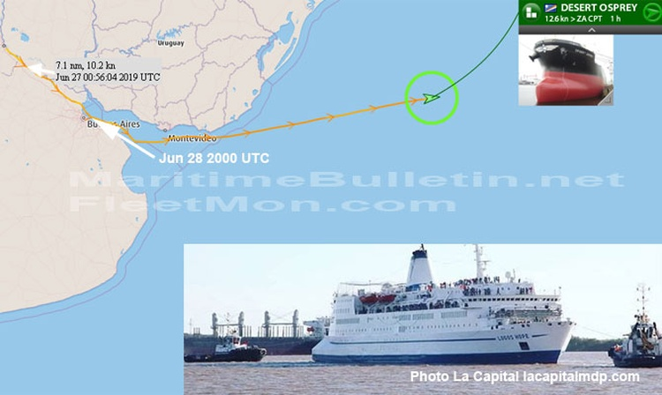
Local media reported collision between biggest in the world floating library LOGOS HOPE and bulk carrier DESERT OSPREY at 408 kilometer mark near Punta Alvear Cargill, Parana river, Argentina. It was a contact, ships brushed each other without inflicting serious damages. Local media dated accident Sat Jun 29, but it’s obviously, a mistake, it should happen earlier, on Jun 26 most probably. LOGOS HOPE reached next port of call after completing Parana cruise, Buenos Aires, in the evening Jun 28, DESERT OSPREY passed Parana river estuary and sailed into Rio de La Plata on Jun 28. Both ships were inspected after accident.
FleetMon Vessel Risk Rating: https://www.fleetmon.com/services/vessel-risk-rating/

ruise ship collision after delivery ceremony, Emden
Posted in Accidents by Mikhail Voytenko on Jun 25, 2019 at 14:16.
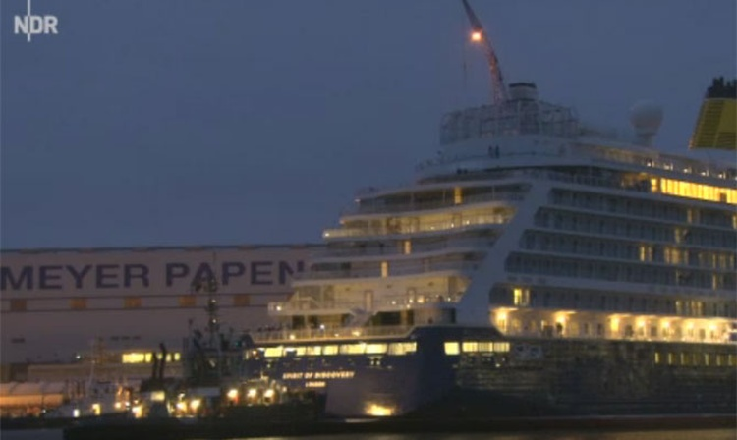
Brand new cruise ship SPIRIT OF DISCOVERY, delivered to SAGA Cruises by builder, Meyer Werft, on Jun 24, yet to be officially christened, collided with bollards at Great Sea Lock while leaving Emden late at night Jun 24, hours after official delivery procedure. The ship sustained superficial damages, abrasions, scratches and a slight dent. Bollards were seriously damaged. The ship left Emden and was brought to anchor off Helgoland, though she was set to sail to Eemshaven, according to schedule. She’s to start her maiden voyage on Jul 10. As of 1400 UTC Jun 25, she was still anchored.
FleetMon Vessel Risk Rating: https://www.fleetmon.com/services/vessel-risk-rating/

ussian nuclear submarine explosion and fire, all on board reported dead
Posted in Accidents by Mikhail Voytenko on Jul 02, 2019 at 14:59.
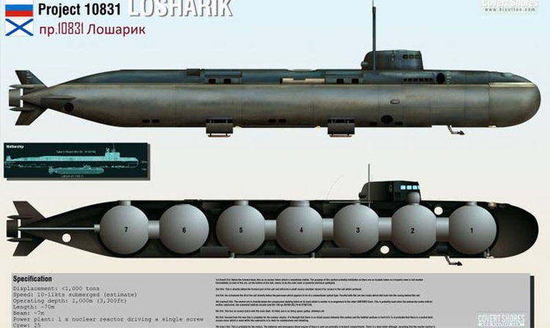
Russian North-West Region local media on Jul 2 reported explosion and fire on board of Russian Navy deepwater nuclear research station or submarine AS-12, known as LOSHARIK. Accident occurred on Jul 1. According to news, all staff on board, up to 14 people, died in explosion and fire. Ministry of Defence didn’t reveal name of underwater vehicle, number of crew or any other details. According to official statement, fire was extinguished or put under control. Submarine or whatever it is, was “carrying out water biometric research in Russian territorial waters", understood in Barents sea.
As of 1430 UTC Jul 2, news are sketchy and contradictory, initial news published by local newspaper Severomorsk Life were removed from newspaper website.
Russian Navy Research nuclear submarine AS-12 (nciknamed LOSHARIK) - nuclear deepwater station of Project 10831. It is powered by a nuclear reactor and is believed to be able to operate at a depth down to 6,000 meters. Displacement 2000 tons submerged, length about 60 meters, complement 25 officers (no private ranks).
FleetMon Vessel Risk Rating: https://www.fleetmon.com/services/vessel-risk-rating/

xplosion and fire on board of Italian LPG tanker
Posted in Accidents by Mikhail Voytenko on Jul 02, 2019 at 04:55.
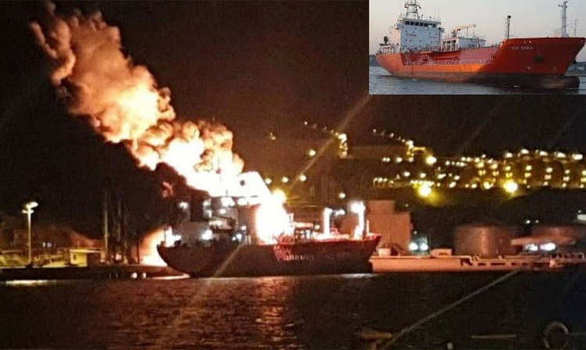
Explosion followed by fire on board of Italian LPG tanker SYN ZANIA claimed 1 life, 15 other crew were evacuated and got medical treatment, no serious injures reported. Tanker was loading LPG cargo at Petkim Refinery terminal, Aliaga, Turkey, explosion occurred at around 2330 LT Jul 1, the cause of explosion yet unknown. Shore engines and fire boats were deployed, fire was reported extinguished by probably, 0200 LT Jul 2. Crew includes 15 Italian and 1 Romanian nationalities.
As of 0440 UTC Jul 2, ship’s AIS was working.
FleetMon Vessel Risk Rating: https://www.fleetmon.com/services/vessel-risk-rating/

Transnet pleased with 29% cruise passenger increase
ECONOMY / 9 JUNE 2019, 07:00AM / GIVEN MAJOLA
- 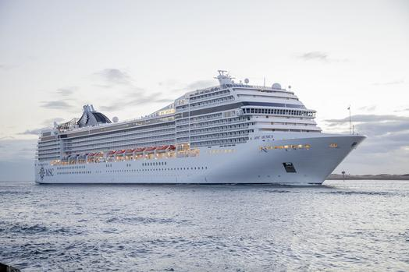
Transnet National Ports Authority in Durban says the 29% cruise passenger increases spell better prospects for the local sector in the future. Pictures Supplied. TNPA
DURBAN - Transnet National Ports Authority(TNPA) in Durban says the 29 percent cruise passenger increases spell better prospects for the local sector in the future.
TNPA has processed 255 422 passenger embarkations and disembarkations at the port of Durban up from the 197 382 recorded in the 2017/2018 season. During the cruise season, which is typically from late October to late April, the port enjoyed 63 calls by 16 different cruise vessels. Durban’s acting port manager Nokuzola Nkowane attributed the passenger growth largely to MSC Cruises, which uses the Port of Durban as a home port. “MSC Cruises had the larger MSC Musica offering her first cruises locally last season. She made 42 calls to the Port of Durban, representing the lion’s share of total embarkations and disembarkations recorded. However, we are proud to have also welcomed 12 other world-class operators to the port last season,” says Nkowane.

In the next season, the cruise will be introducing yet another vessel, called the MSC Orchestra, with which it intends to entice cruise tourists to return for their next adventure. Dineo Mazibuko, the senior manager for Corporate Services at the Port of Durban, says the inbound cruise tourists generally depend on the cruise line sailing in and the voyage it was on. These tourists were typically from the US, the UK, Italy, Germany and other European countries. The Port of Durban says it is also seeing a growing interest every year among domestic tourists who take cruises. Most of them were said to be sailing on the local cruises provided by MSC Cruises from Durban and Cape Town to various locations including Mauritius, the Reunion Islands, and Mozambique’s Pomene Bay and Portuguese Island.
Nkowane says investments made by the TNPA and MSC Cruises into the Port of Durban are aimed at attracting more cruise line companies to the city and Southern Africa as a whole. The cruise liner itineraries were planned at least two years in advance with exciting local excursions being the biggest draw cards. New cruise vessels were promising a different experience over the suitable port infrastructure. The KwaZulu Cruise Terminal (KCT) consortium, in which MSC is a partner, holds a 25-year port concession from TNPA to finance, construct, operate, maintain and transfer a new Cruise Terminal Facility in the Port of Durban at an estimated value of more than R200 million. Nkowane’s says KCT is presently finalising the detailed design of the Cruise Terminal Building with the anticipated commissioning of the project set for next year. Capital investment for the new Durban cruise terminal project by KwaZulu Cruise Terminal has been estimated at R200 million. The current passenger facility, N-Shed, was also upgraded jointly by TNPA and MSC Cruises ahead of the 2015/16 season. Amongst the challenges encountered throughout the past season, Mazibuko says the existing cruise terminals are situated within a cargo operational area of the port.

“The cruise hub ports of Cape Town and Durban are undergoing significant facelifts to address these challenges and to become more competitive against other global and national players,” she says.

Mazibuko says other challenges include restricted access to transport, coaches and local tourist experiences.

However, she says, South Africa offers a myriad of lifestyle and tourism prospects for visitors, which includes local excursions, restaurants and shopping experiences.

The last SA Cruise Tourism Report of 2010, predicted that cruise passenger throughput could increase to 1 million passengers by 2025 Durban and Cape Town expected to achieve the highest market share.

An analysis based on medium-passenger projections reveal that total net benefits to the country are worth R41.3m in 2010 and could increase to total R356.4m by 2025.

The cruise industry value chain assessment commissioned by Durban’s eThekwini Municipality and conducted by business management consultant Grant Thornton, the Durban cruise industry is estimated to account for 2 700 jobs in the tourism sector. Direct spend of the Durban cruise industry for 2013 was R1.38 billion (of which passenger spend accounted for R1.3bn) , which pointed to good growth opportunities.

The Grant Thornton study reiterated that cruise tourism was one of the world’s fastest growing tourist activities, enjoying dynamic growth over the past 30 years. It also highlighted that there was increased demand for new cruise destinations and increased interest in African cruise destinations in particular.

In its October 2016 outlook, KZN Tourism said that passenger spend while in port, on shopping and excursions, was a valuable contribution to the tourism economy of the province. Even more valuable, however, was the re-provisioning of the ships while in port. That activity creates value in a wide range of economic sectors ranging from fuel, to water, to foodstuffs, wine and other beverages, ship-board shops restocking and the like.

A study done on cruise tourism revealed the following that for passengers and crew, there was an average shore spend of R1m to R2m per day per cuise ship port-of-call.

For reprovisioning, there was a potential spend of approximately R3mm per cruise ship port-of-call. Reprovisioning provides up to four times the value of passenger spend.

The year just concluded, 2018, was a record year for the global cruise industry, which did not only show strong growth in passenger bookings and fares, but onboard revenues that continued to be one of the key revenue drivers for the leading cruise companies.

The industry trade group, Cruise Lines International Association (CLIA), reported nearly 6 percent growth with more than 1.5 million passengers in 2018 driven in part by the addition of 11 new ships with more than 30000 berths. CLIA was forecasting consistent growth of better than 6 percent in 2019 to 30 million passengers worldwide. Wells Fargo Securities financial analyst Timothy Conder told investors in a March equity report that strong secular growth trends for experiences, multi-generational and family travel continued to drive the industry’s growth. The cruise industry is increasingly working with the destinations as it seeks to ensure that passengers can have unique experiences. They are also supporting efforts to expand port infrastructure to meet the needs of more and larger cruise ships.

BUSINESS REPORT

